Society of Western Artists

RULES ON FRAMING FOR SWA SHOWS

SWA Judges look at frames and matting along with your artwork. Many times paintings are not accepted into shows due to poor framing and matting. Before you bring in your painting check the overall look of your artwork. Artists have brought in paintings with frames that don’t compliment the painting or are scratched/chipped, artwork falling out of frames, dirty or spotted mats, buckled watercolor paintings, dirty glass, etc. Use one solid wire on your paintings to hang. One artist used 2 pieces and wound them together in the middle. The wires eventually slipped apart and the painting fell, destroying the glass.

SWA is a professional organization. Make your artwork look as professional as possible!

FRAMING RULES
- Size: Frame outside dimensions for all paintings are limited to:
  - Not less than 10 inches (ANNUAL EXHBITION ONLY - 16 inches)
  - Not larger than 48 inches (ANNUAL EXHIBITION ONLY – 60 inches)
- Metal Frames – full sheet (22”x30”) or larger must use plexiglass.
- Hardware – Hardware for hanging must be flat type. SEE PHOTOS BELOW
  - No nails, eye screws, or protruding hardware allowed.
- Wires – All paintings must be wired for hanging. Use one piece of wire for hanging. Hanger wires ends must be taped or covered with plastic sleeves.
- Paper Artwork - must be properly mounted to support. No scotch tape or other visible adhesives allowed.
- Works on Canvas or Panel - Must be securely mounted within frame rabbet. Taping artwork into frame is not allowed.
- No oil paintings under glass.
- No paintings over photographs.
- All artwork MUST be dry. Wet paintings will not be accepted.

Acceptable - Flat Wire Hanger with Taped Wire Ends Not Acceptable – Eye Screws

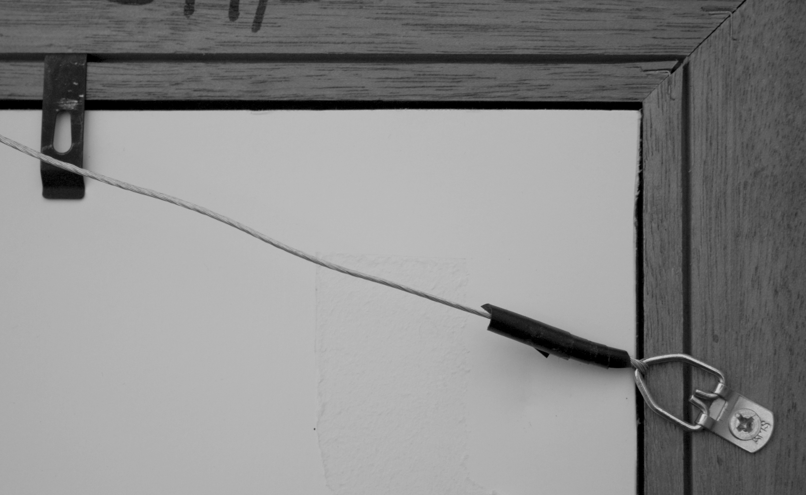
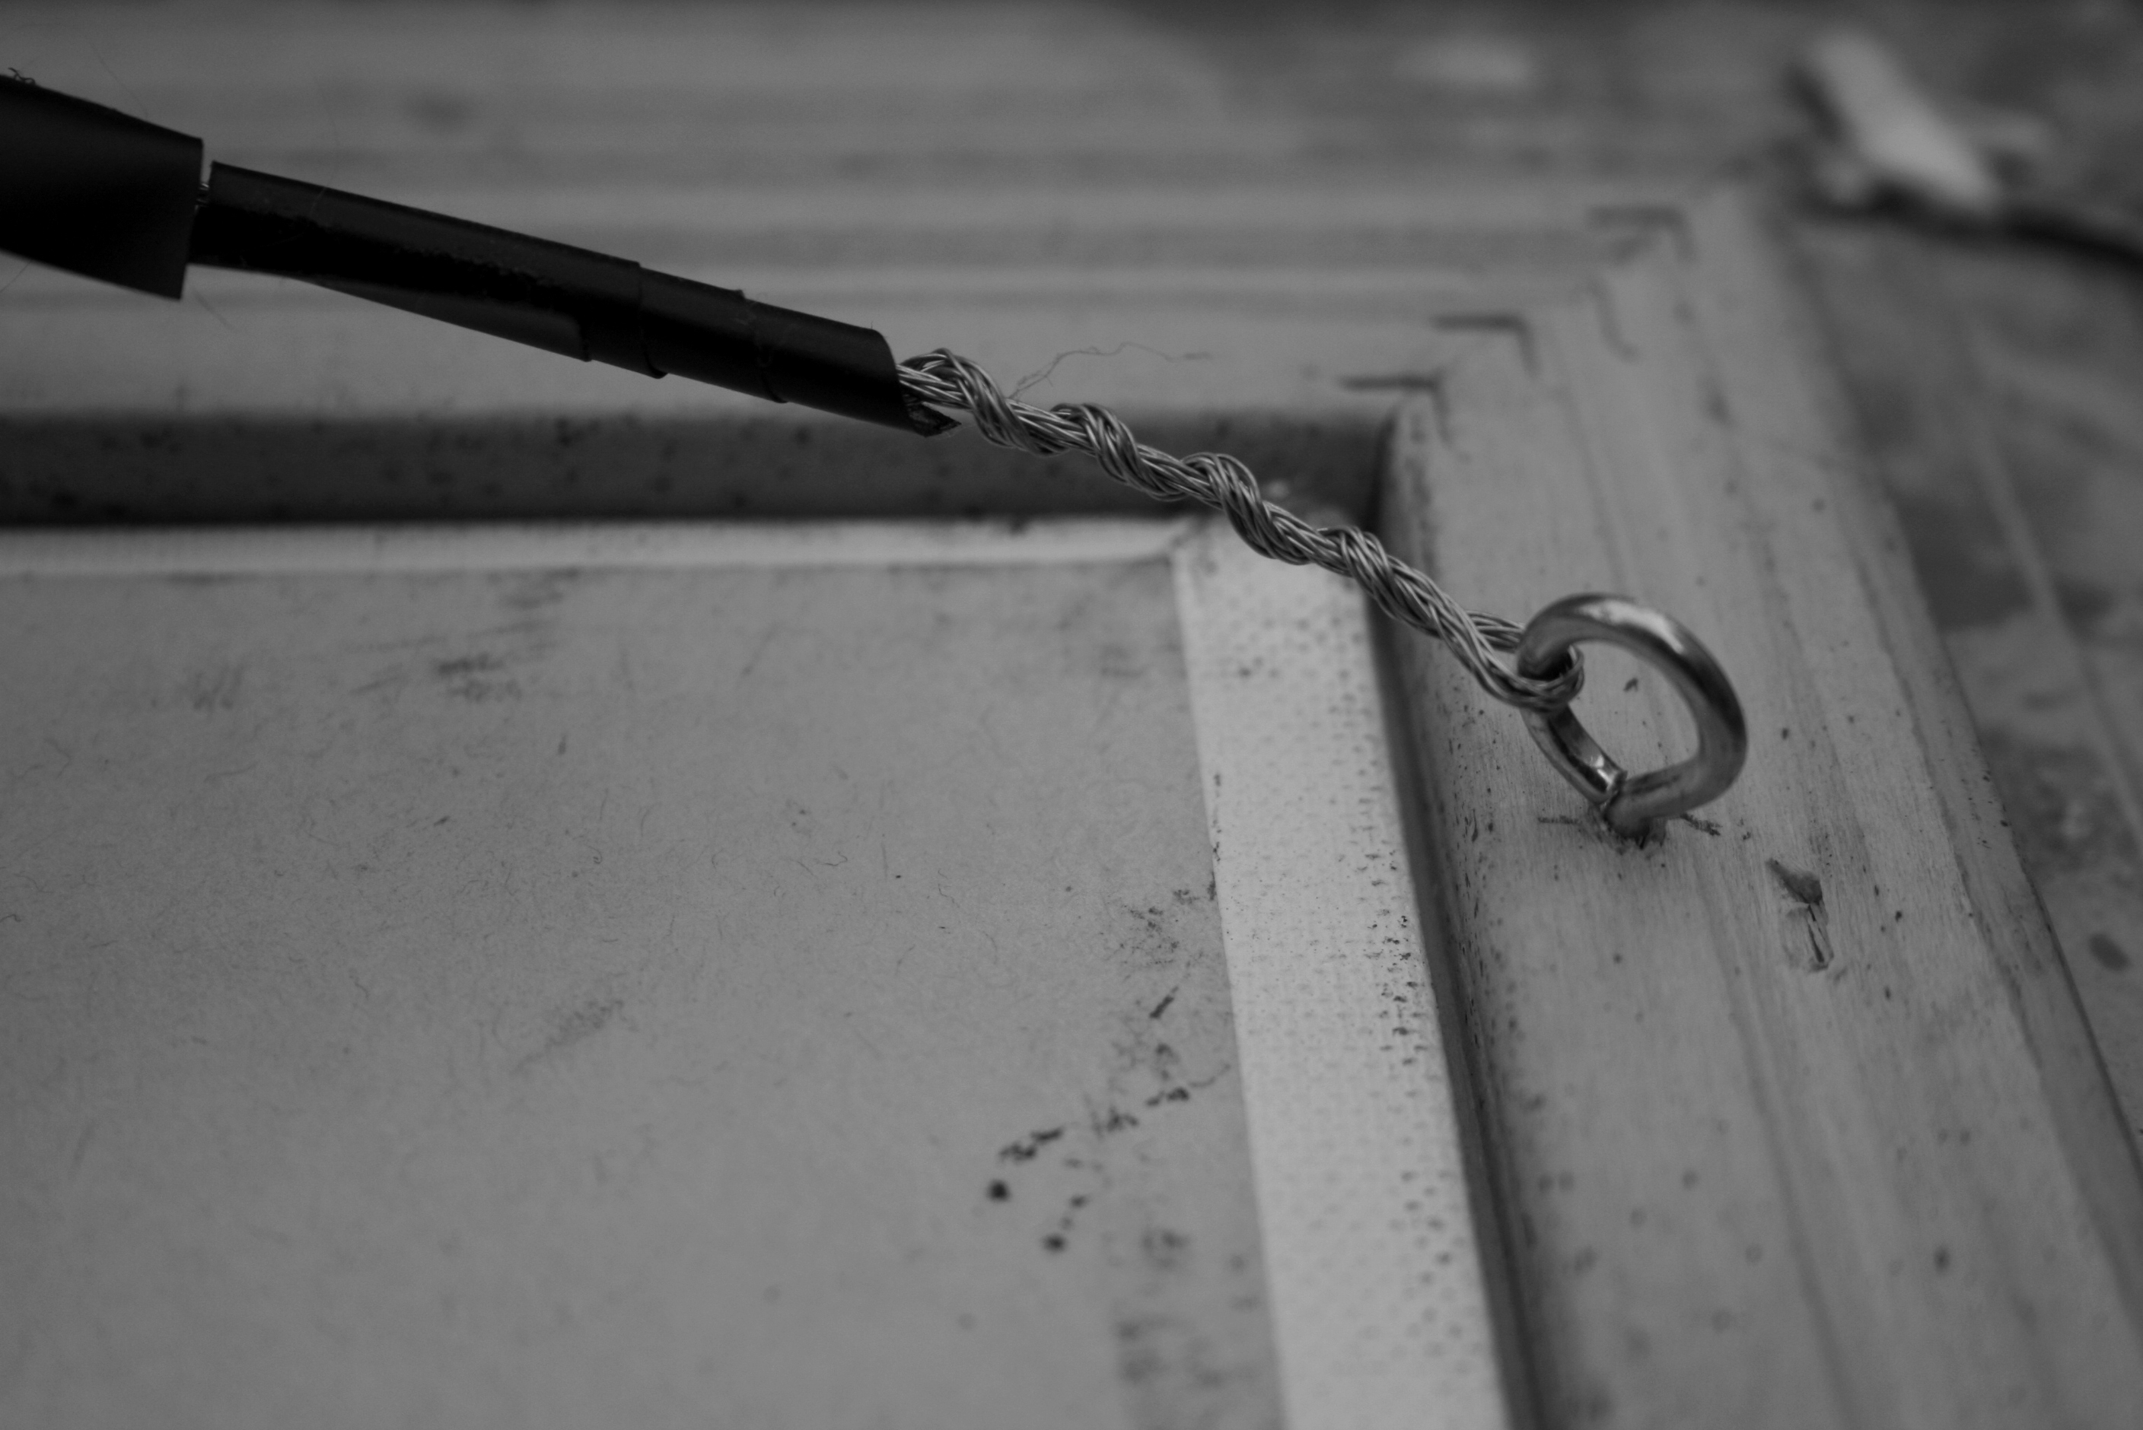

MAT COLORS FOR ARTWORK: White or off-white mats are encouraged. A small (1/4”) inner mat border is acceptable.

Paintings with a religious or political theme are not acceptable. Artwork may be representational or abstract.

ARTWORK NOT MEETING THE ABOVE REQUIREMENTS WILL BE DISQUALIFIED FROM SWA SHOWS.

